# INVESTIGATION OF SURFACE INTIGRITY OF POWDER MIXED EDM OF NICKEL BASED SUPER ALLOY USING CHROMIUM POWDER

*Report submitted to the SASTRA Deemed to be University as the requirement for the course*

## MEC300-MINI PROJECT WORK

*Submitted by*

## NAME: K. BHASWANTH

## (Reg. No.: 124009059)

**NAME: P.V.S. PRANEETH**

**(Reg. No.: 124009142)**

**NAME: B. CHANAKYA**

**(Reg. No.: 124009284)**

MAY 2023



SCHOOL OF MECHANICAL ENGINEERING

## THANJAVUR, TAMIL NADU, INDIA – 613 401



**SCHOOL OF MECHANICAL ENGINEERING**

**THANJAVUR – 613 401**

## Bonafide Certificate

This is to certify that the report titled **“Investigation of surface integrity of powder mixed EDM of nickel based supper alloy using chromium powder ”** submitted as a requirement for the course, **MEC300: MINI PROJECT** for B.Tech. mechanical programme, is a bonafide record of the work done by **Mr.K.Bhaswanth(Reg.No.124009059), Mr. P.V.S.Praneeth(Reg.No.124009142) , Mr.B.Chanakya Reddy(Reg.No.124009284)** during the academic year 2022-23, in the School of Mechanical Engineering under my supervision.

## Signature of Project Supervisor :

## Name with Affiliation :Dr. S Ramesh

**Date :10-05-2023**

Project *Viva voic*e held on

## Examiner 1 Examiner 2



**SCHOOL OF MECHANICAL ENGINEERING**

**THANJAVUR – 613 401**

## Declaration

We declare that the report titled **“Investigation of surface integrity of powder mixed EDM of nickel-based supper alloy using chromium powder”** submitted by us is an original work done by us under the guidance of **Dr S. RAMESH, Assistant Professor III, School of Mechanical Engineering, SASTRA Deemed to be University** during the sixth semester of the academic year 2022-23, in the **School of Mechanical Engineering**. The work is original and wherever We have used materials from other sources, We have given due credit and cited them in the text of the report. This report has not formed the basis for the award of any degree, diploma, associate-ship, fellowship or other similar title to any candidate of any University.

## Signature of the candidate(s) :

## Name of the candidate(s) : K. Bhaswanth

## P.V.S. Praneeth

## B. Chanakya Reddy

## Date :18-05-2023

**Acknowledgement**

With the blessings of Almighty, we wish to extend my sincere gratitude to our Honourable Vice Chancellor, **Dr. S. Vaidhyasubramaniam**, SASTRA Deemed to be University, without whom I would have not had such an opportunity. We also wish to extend my sincere gratitude to our Registrar, **Dr. R. Chandramouli**, SASTRA Deemed to be University, for all the good wishes towards the successful completion of the study. We owe our hearty thanks to Dr. S. Pugazhenthi, Dean, School of Mechanical Engineering, SASTRA Deemed to be University for his valuable support and directions given throughout the period of my project work. We are deeply indebted to my project guide, **Dr. Ramesh S**, **Assistant Professor - 3** School of Mechanical Engineering, SASTRA Deemed to be University for his valuable guidance, encouragement and motivation in successful accomplishment of this project. We express my heartfelt thanks to all the **faculty members**, **Technical Assistants and Non-Teaching Staff** for their valuable and timely assistance. Last but not the least, I thank my **Parent, Friends** and People who are not under the scene but have helped in the successful fulfillment of this project.

**Abstract**

Electric Discharge Machining (EDM) is one of the important non-conventional machining processes which uses electrical energy instead of mechanical force to remove material from a workpiece. since this process removes materials through the spark erosion technique and its ability to produce complex shapes with no vibration of the tool or workpiece this process is most suitable for machining hard and difficult to- cut materials. . However, this machining process also has some limitations like poor surface finish and low material removal rate. To overcome the above-mentioned drawbacks, the powder-mixed electric discharge machining technique had been developed. This work mainly investigated the performance of powder mixed EDM of Nickel based super alloy, Nimonic75, with chromium powder. Nimonic75 mainly employed in gas turbines and aerospace engineering applications. The performance of the PMEDM was assessed by measuring the surface roughness and the hardness of the machined components. Parameters considered for analysis are the concentration of powder (Cp), peak current (Ip), and pulse on time (Ton).

# Specific Learning:

Signature of the Guide Student Reg. No:

Name: Name:

# Table of Contents

## Title Page No.

Bonafide Certificate ii

Declaration iii

Acknowledgement iv

Abstract v

List of figures vi

List of Tables vii

Abbreviations viii

1. Introduction

1.1. Overview 1

1.2. EDM 1

1.3 Advantages & Disadvantages 2

1.4 Powder mixed EDM 3

1.5 Powder Mixed EDM working process 3

1.6 Parameters 3

1.7 Motivation 4

1. Objective & scope of the work
   1. Objective 5
   2. Literature Survey 5
2. Experimental work / Methodology
   1. Methodology 6
   2. Powder mixed EDM process 6
   3. Measurement of surface roughness 7
   4. Measurement of hardness value 7

1. Results and Discussion
   1. Results 8
   2. Discussion 16
2. Conclusion and Future scope

5.1 Conclusion 17

1. References

6.1 References 18

1. Appendix

7.1 Self-Evaluation for group work 19

7.2 Peer Evaluation for group work 22

# List of Figures

|  |  |  |
| --- | --- | --- |
| **FIG.No** | **Title** | **Pg.No** |
| 3.1 | Experimental setup of EDM Machine | 8 |
| 4.1 | Model Summary of Surface Roughness | 11 |
| 4.2 | Regression Equation of Surface Roughness | 12 |
| 4.3 | Graph of concentration of powder vs peak current of surface roughness | 12 |
| 4.4 | Graph of concentration of powder vs Pulse on Time of Surface roughness | 13 |
| 4.5 | Graph of peak current vs Pulse on Time of Surface roughness | 14 |
| 4.6 | Model Summary of Hardness | 15 |
| 4.7 | Regression equation of Hardness | 16 |
| 4.8 | Graph of concentration of powder vs peak current of hardness | 16 |
| 4.9 | Graph of concentration of powder vs pulse on time of hardness | 17 |
| 4.10 | Graph of peak current vs pulse on time of Hardness | 18 |

# LIST OF TABLES

|  |  |  |
| --- | --- | --- |
| TABLE No. | Title | Pg No. |
| 3.1 | Chemical Composition of Nimonic75 alloy | 6 |
| 3.2 | Physical properties of Nimonic75 | 7 |
| 3.3 | Physical properties of copper tool electrode material | 7 |
| 3.4 | Experimental Conditions | 8 |
| 3.5 | Process variables | 9 |
| 4.1 | Parameters Level | 10 |
| 4.2 | Surface Roughness Values | 11 |
| 4.3 | Hardness values | 15 |

**ABBREVIATIONS**

* EDM – Electrical Discharge Machining.
* PMEDM – Powder Mixed Electrical Discharge Machining.
* Ra – Surface Roughness.
* TWR – Tool Wear Rate.
* IP – Peak current.
* MRR – Metal Removal Rate.
* Pc – Concentration of Powder.
* TON – Pulse on Time.
* TOFF – Pulse off Time.
* SON – Spark on Duration.
* SOFF – Spark off Duration.

**CHAPTER 1**

**INTRODUCTION**

* 1. **EDM:**

Electrical Discharge Machining (EDM) is an important non-traditional machining process widely used for producing complex shapes in hard and electrically conductive materials. In EDM, a series of high-frequency electrical discharges are generated between a tool (electrode) and a workpiece, resulting in the controlled removal of material through localized melting and vaporization.

EDM operates on the principle of erosion, where the material is removed in small increments. The tool, typically made of copper or graphite, is guided close to the workpiece, and a dielectric fluid (such as deionized water or hydrocarbon oil) is used to flush away the debris and cool the machining area. This dielectric fluid also acts as a medium for the electrical discharges to occur. It is particularly useful in industries such as aerospace, automotive, and tooling, where high precision and intricate shapes are required.

EDM offers various machining techniques, including die-sinking EDM and wire EDM. In sinker EDM, the tool and workpiece are submerged in the dielectric fluid, and the tool's shape is transferred to the workpiece by repeated sparking. Wire EDM, on the other hand, uses a thin wire as an electrode, which is fed continuously to cut through the workpiece. This technique is suitable for producing intricate profiles and thin sections. Surface finish and accuracy are critical aspects of EDM.

The process can achieve fine surface finishes, often surpassing the capabilities of other machining methods. However, the surface finish can be affected by factors such as electrode wear, flushing conditions, and the choice of dielectric fluid. Achieving the desired surface finish requires a careful selection of process parameters, including the voltage, current, and pulse duration. In addition to surface finish, another area of interest in EDM research is the micro hardness of the machined surface. EDM can result in work-hardening effects, altering the microstructure and hardness of the material. Understanding and optimizing the micro hardness properties can have implications for the overall performance and durability of the machined components.

Overall, EDM is a versatile and precise machining process suitable for a wide range of applications. Ongoing research and development aim to further improve the process parameters, tooling materials, and surface characteristics, expanding the capabilities and potential applications of EDM in modern manufacturing.

* 1. **Advantages & Disadvantages of EDM:**

Advantages:

* It can be applied to all electrically conducting materials.
* Any complex shapes can be machined.
* Ability to work with extremely hard materials.
* No mechanical stresses due to no contact between tool and workpiece.
* Hard and Corrosion-resistant surface can be attained.

Disadvantages:

* Machining time is too long.
* Excessive Tool wear (TWR).
* Only machining for conductive materials.
* Poor surface Finish.

By above mentioned disadvantages like low Metal Removal Rate (MRR), high tool wear rate and to increase in surface finish of EDM process scientists used mixing of powder to dielectric fluid. i.e., Powder Mixed EDM process.

* 1. **Powder Mixed EDM:**

Electrically Discharge Machining (EDM) is a good process for manufacture of hard materials with complex shapes without any vibration, mechanical stresses, chatters. But because of disadvantages like high tool wear rate, low material removal rate and to increase the surface finish researchers come with up a concept of powder mixed EDM process. Powder-mixed EDM is an innovative variant of the EDM process that incorporates the introduction of a conductive powder into the machining zone. The powder materials like graphite, aluminum, silicon etc., assists in improving machining performance and surface quality. By adding the powder, the EDM process can enhance material removal rates, reduce electrode wear, and influence the surface characteristics of the workpiece. The powder acts as a reinforcement, aiding in the erosion process and modifying the discharge behavior. This technique has shown remarkable improvement by achieving better surface finishes, reduced tool wear, and enhanced machining rate. Ongoing research focuses on optimizing the powder composition, concentration, and process parameters to harness the full potential of powder mixed EDM in precision manufacturing.

* 1. **Powder Mixed EDM process:**

Powder Mixed EDM process in which conductive powder is added to the dielectric fluid. Metallic powder in dielectric fluid decreases the insulation strength and increases the gap between electrode and workpiece which helps to improve the EDM performance and surface finish rather than the normal EDM process.

The working principle of powder mixed EDM process is that the required voltage an electric filed is produce which gives rise to positive and negative charges on the powdered particles. These particles move in the zig-zag manner which helps to improve in the spark gap between electrode and workpiece. Interlocking between different powder particles forms a chain that leads to an early explosion in the gap. The combined effect of particle bridging and suspended additive particles reduces the discharge power density and pulse implosive gas pressure.

* 1. **PMEDM Parameters:**

In powder mixed EDM process, two types of parameters should be considered which are process parameters and performance parameters. Process parameters like peak current, pulse on time, pulse off time, pulse wave length, type of powder, powder concentration, electrode material, electrode shape. By these process parameters, performance of the powder mixed EDM process is significantly impacted. in general, material removal rate, tool wear rate, surface roughness, surface hardness is considered as the performance measures.

But we considered the electrical parameters peak current, pulse on time and powder-based parameter powder concentration is considered.

* **Peak Current (IP):** It is the maximum current that is supplied to the electrodes during the discharge. It is the important parameter because it affects the time of discharge and intensity, it affects the removal rate and the surface finish of the machining workpiece. Peak current also depends on several factors type of material, electrode material, type of concentration of conductive powder used.
* **Pulse on Time (TON):** Pulse on Time is the duration of the electrical discharge supplies between electrode and workpiece. It affects the energy delivered to the workpiece. It affects the material removal rate and surface finish on machined surface. It depends on factors like material being machined, geometry of the workpiece, type of powder and concentration of the powder used in the process.
* **Concentration of Powder:** The amount of powder present in the dielectric fluid used in the powder mixed EDM process. It depends on material being machined, size of the workpiece, size of the powder particles used. It shows effect on the electrode wear and surface finish and hardness.
* **Motivation:**

The EDM process is good on several aspects, however, also, they are some disadvantages also like metal removal rate, high tool wear rate, etc. To rectify the above-mentioned disadvantages, The proposed work used the powder mixed EDM process to machine the nickel-based superalloy material.

**CHAPTER – 2**

**OBJECTIVE**

* 1. **OBJECTIVE:**

The current project work aimed to investigate the surface integrity of chromium Powder Mixed EDM process on Nickel based Superalloy (Nimonic75), with considering the process parameters such as concentration of powder, peak current, and Pulse on Time.

* 1. **LITERATURE SURVEY:**
* Anand Y. Joshi et al December 2019.
* Ramesh. S et al. 2018.
* Pragya shandiliya et al. 20th October,2021.

**CHAPTER 3**

**EXPERIMENTAL DESIGN**

**3.1 RESPONSE SURFACE METHODOLOGY:**

The aim of response surface methodology (RSM) is to optimize the response of a process or system by identifying the factors that affect the response and determining the levels of those factors that will produce the desired response. RSM can be used to optimize a wide variety of processes, including manufacturing, chemical engineering, and medical research.

RSM typically involves the following steps:

* Identify the factors that affect the response.
* Choose a design for the experiments.
* Conduct the experiments.
* Analyze the data.
* Optimize the response.

RSM is a powerful tool that can be used to improve the efficiency, reduce the cost and improved the quality. It is important to have a good understanding of the process or system that is being optimized before using RSM.

**3.2 NIMONIC75 SUPERALLOY:**

Nimonic75 is nickel based super alloy. This alloy, known for its excellent creep resistant properties, has nearly 75% of Nickel next major constituent in the alloy is chromium which is 18-21 %. Besides that, the other constituent is Titanium which is added to strength and alloy.

|  |  |  |  |  |  |  |  |
| --- | --- | --- | --- | --- | --- | --- | --- |
| **Constituents** | **Ni** | **Cr** | **Ti** | **C** | **Si** | **Cu** | **Fe** |
| Wt% | 75 | 18-21 | 0.2-  0.6 | 0.8-  0.15 | 1.0  max | 0.5  max | 5.0  max |

Table 3.1 Chemical composition of Nimonic75 alloy

The following properties of the Nimonic75 super alloy material render it highly difficult to machine through any conventional machining process.

* High strength.
* High Hardness.
* High Tool Wear Rate.

EDM process has been widely used by many manufactures so we choose to investigate the machinability of Nimonic75 alloy, under powder mixed dielectric conditions.

**3.3 EXPERIMENTAL DETALS:**

From the above studies that the physical properties are showing the strong influence on the process outcome. So, we decided to get the physical properties which are showing the effect on the outcome. The properties, Melting Point, Density, Thermal Conductivity effects the machining efficiency.

|  |  |
| --- | --- |
| **Physical Properties** | **Nimonic75 alloy** |
| Density (g/cc) | 8.37 |
| Melting Point (ºC) | 1350 |
| Thermal Conductivity (W/m-K) | 11.7 |

Table 3.2 physical properties of Nimonic75.

There is also effect of tool material on the mechanism of PMEDM. The tool electrode material is Copper and its physical properties such as Density, Melting point, Electrical Conductivity.

|  |  |
| --- | --- |
| **Physical Properties** | **Copper (Cu)** |
| Density (g/cc) | 8.94 |
| Melting Point (ºC) | 1085 |
| Electrical Conductivity (S/m) at 20ºC | 5.85 x 107 |

Table 3.3 Physical properties of copper tool electrode material.

The experiment was carried out by chromium powder mixed into the dielectric fluid to understand the effect of work material and tool material under PMEDM process. The properties such as chemical inertness, Hardness, corrosive resistance makes to select the chromium powder.

Since the experiments are to machine the work material under powder mixed condition, a separate tank was fabricated. The dielectric fluid used in the experiment is kerosene. This will avoid the contamination of entire dielectric liquid in the collection tank of the EDM machine by the conductive powder used.

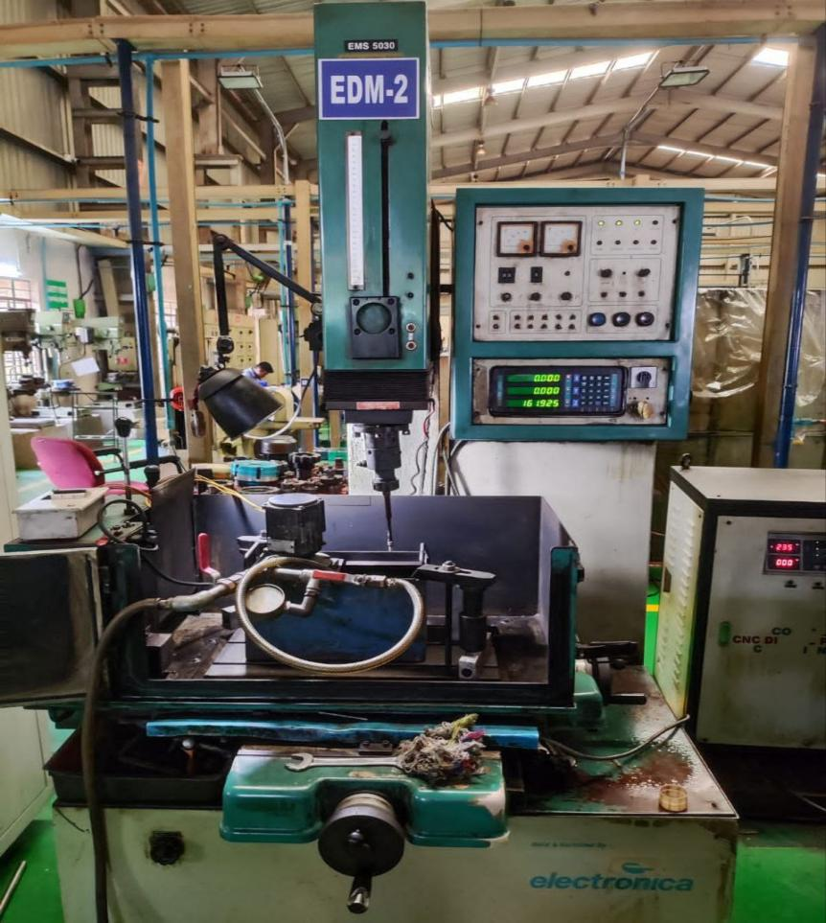

FIG.3.1 Experimental setup of EDM.

The small fabricated tank capacity is 5 litres and was fitted with a small pump and other necessary mountings by which the flow rate of the kerosene was controlled. The tool electrode copper used in the experiment were machined for 10mm diameter precisely.

The other process parameters considered in experiment were concentration of chromium powder, Peak current and Pulse on Time.

|  |  |
| --- | --- |
| Sparking Voltage | 40V |
| Tool Polarity | Negative |
| Dielectric used | Kerosene |
| Work material polarity | Positive |
| Pulse off time | 9µs |
| Powder | Chromium |
| Experimental Design | Response Surface Methodology |

Table 3.4 Experimental condiotions

* **Process Variables:**

Table 3.5 Process variables.

|  |  |  |  |
| --- | --- | --- | --- |
| **Parameters** | **Level 1** | **Level 2** | **Level 3** |
| Concentration(g/l) | 0 | 3 | 6 |
| Discharge Current(A) | 2 | 4 | 6 |
| Pulse on Time(µs) | 10 | 30 | 50 |

**3.4 SURFACE ROUGHNESS TEST:**

The technique of measuring a work pieces or material’s surface imperfections is known as surface roughness testing. A surface roughness tester or profilometer is the instrument that is most frequently used for this purpose.

The surface needs to be cleaned thoroughly to get the most accurate results then the machine needs to be calibrated to ensure accurate measurements of the surface roughness. Select the suitable parameters then place the probe on the surface of the work piece make sure that has contact with the work piece and gently move it along the surface in the direction of the test.

After taking the measurements analyse the results in the Minitab and plot the required graphs of surface roughness and parameters considered to study the surface roughness of the PMEDM.

**3.5 HARDNESS TEST:**

A non-destructive testing technique called micro hardness testing examines a material’s hardness on a microscopic scale, usually at the micro-structural level.

The micro hardness testing machine must be setup and need to be calibrated according to the manufacturer’s instructions. The test parameters such as load, dwell time and indentation pattern must be selected according to the properties of the materials then placing work piece on the machine positioning the indenter over the area of the machined surface and load is applied. After the dwell time the load will be released gradually and the indenter will be removed from the surface and results can be seen on the screen of the micro hardness tester. While our samples are small in size it is mandatory to check whether we are getting proper indentation or not.

After taking the measurements analyse the results in the Minitab and plot the required graphs of micro hardness and parameters considered while machining.

**CHAPTER 4**

**RESULTS AND DISCUSSION**

**4.1 Results:**

We use Minitab Software to compare the surface roughness with parameters concentration of powder, peak current, pulse on time and get the Model summary, Regression equation and graphs which shows the relation between the surface roughness and parameters.

**Model Summary:** A model Summary is automatically generated when running a regression modeling or a classification modelling. It displays the name of the model, model type and model formula. Appropriate statistics for model also will be generated this shows how well the model fits the data and also compare one model with another of same type.

**Parameters Level:**

|  |  |  |  |
| --- | --- | --- | --- |
| **Parameters** | **Level 1** | **Level 2** | **Level 3** |
| Concentration(g/l) | 0 | 3 | 6 |
| Discharge Current(A) | 2 | 4 | 6 |
| Pulse on Time(µs) | 10 | 30 | 50 |

TABLE – 4.1 Parameters level

* Concentration is taken in gram per liter (g/l).
* Discharge current is taken in Amperes (A).
* Pulse on Time is taken in micro seconds (µs).
* **Surface Roughness Results:**

|  |  |  |  |
| --- | --- | --- | --- |
| **Concentration of powder** | **Peak current** | **Pulse on time (Ton)** | **Surface Roughness** |
| 0 | 2 | 30 | 2.51 |
| 0 | 4 | 10 | 3.14 |
| 0 | 4 | 50 | 3.19 |
| 0 | 6 | 30 | 3.65 |
| 3 | 2 | 10 | 2.02 |
| 3 | 2 | 50 | 2.30 |
| 3 | 4 | 30 | 2.67 |
| 3 | 4 | 30 | 2.68 |
| 3 | 4 | 30 | 2.64 |
| 3 | 6 | 10 | 3.11 |
| 3 | 6 | 50 | 3.34 |
| 6 | 2 | 30 | 2.19 |
| 6 | 4 | 10 | 2.46 |
| 6 | 4 | 50 | 2.67 |
| 6 | 6 | 30 | 2.73 |

TABLE – 4.2 Surface roughness Results.

* **Model Summary of Surface Roughness:**

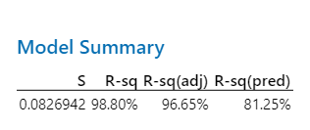

FIG.4.1

* **Regression Equation of Surface Roughness:**

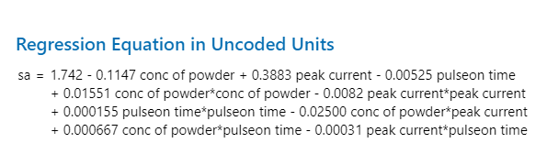

FIG.4.2

* **Graph of Surface Roughness VS Concentration of powder & Peak Current.**

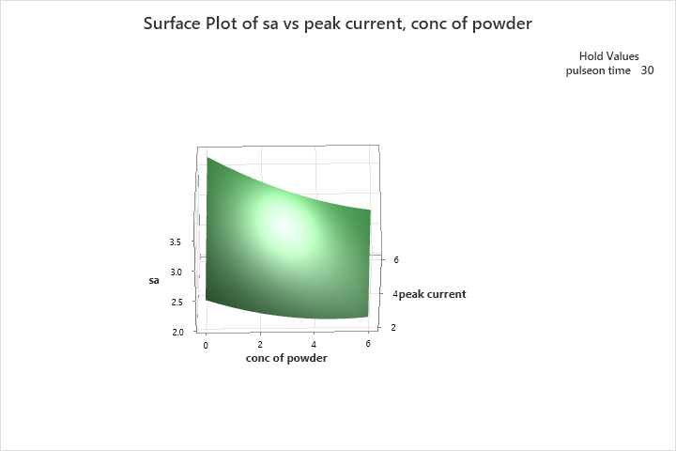

FIG.4.3

* From Graph by increasing the concentration of powder surface roughness value is decreasing it is the good sign that the surface roughness is decreased after machined.
* But whereas by increasing the peak current the surface roughness is also increasing so the peak current should be optimum.
* **Graph of Surface Roughness VS Concentration of powder & Pulse on time:**

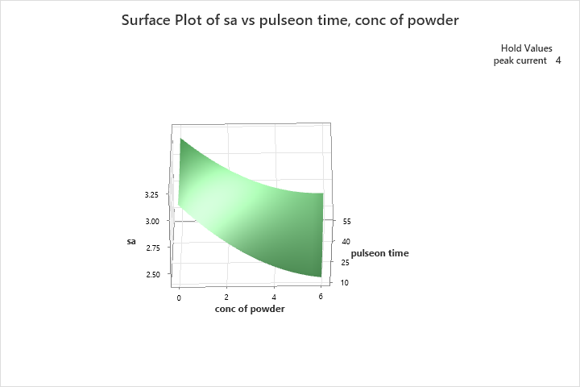

FIG.4.4

* From Graph by increasing the concentration of powder surface roughness is decreasing so increase in concentration of powder showing good sign that surface roughness is decreasing.
* But by increasing the Pulse on time surface roughness is also increases so the pulse on time should be optimum it should not be more.
* **Graph of Surface Roughness VS Peak current & Pulse on Time:**

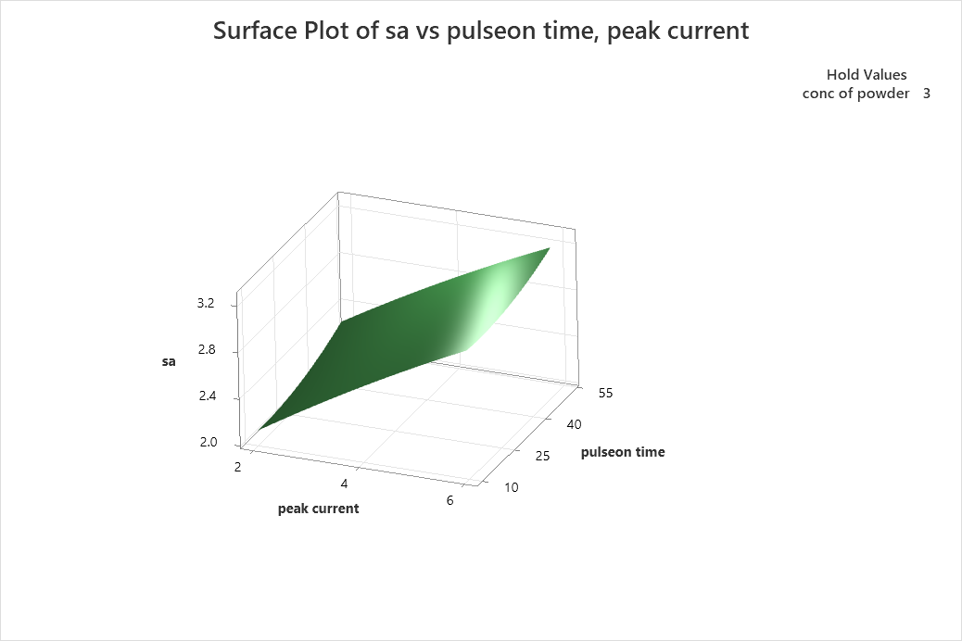

FIG.4.5

* By increasing the peak current surface roughness is increasing so the peak current should be optimum.
* By increasing the pulse on time surface roughness is also increasing so the pulse on time should be optimum.
* **HARDNESS RESULTS:**

|  |  |  |  |
| --- | --- | --- | --- |
| **Concentration of Powder** | **Peak Current** | **Pulse on Time** | **Hardness** |
| 0 | 2 | 30 | 258 |
| 0 | 4 | 10 | 292 |
| 0 | 4 | 50 | 303 |
| 0 | 6 | 30 | 311 |
| 3 | 2 | 10 | 315 |
| 3 | 2 | 50 | 330 |
| 3 | 4 | 30 | 342 |
| 3 | 4 | 30 | 346 |
| 3 | 4 | 30 | 351 |
| 3 | 6 | 10 | 361 |
| 3 | 6 | 50 | 388 |
| 6 | 2 | 30 | 393 |
| 6 | 4 | 10 | 402 |
| 6 | 4 | 50 | 436 |
| 6 | 6 | 30 | 501 |

TABLE – 4.3 Hardness Results

* **Model Summary of Micro Hardness:**

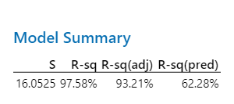

FIG.4.6

* **Regression Equation of Micro Hardness:**

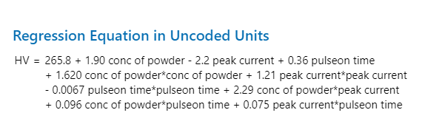

FIG.4.7

* **Graph of Micro Hardness VS Concentration of Powder & Peak Current:**

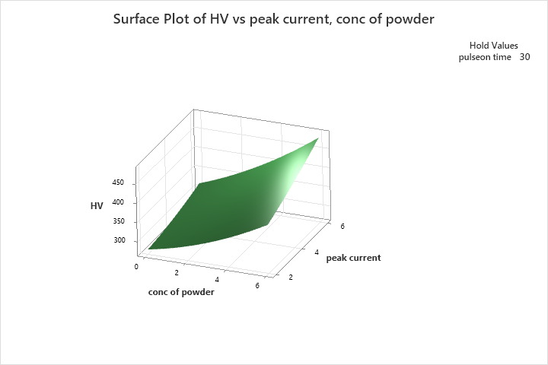

FIG.4.8

* From Graph by increasing the concentration of powder micro hardness is increasing it is a good sign that hardness is increasing after machining so increasing the concentration of powder results in increase in hardness.
* By increasing the peak current hardness is also increasing so it is good sign that hardness is increasing on machined area.
* **Graph of Micro Hardness VS Concentration of Powder & Pulse on Time:**

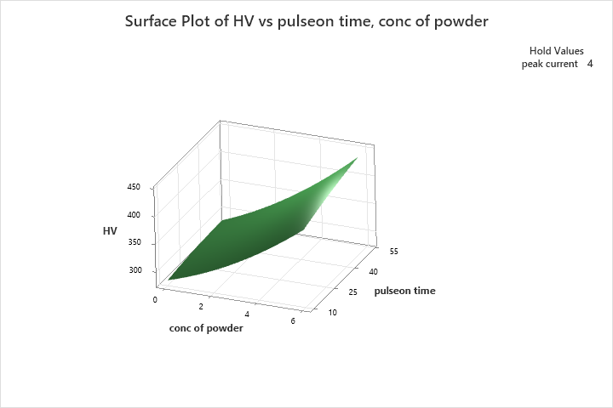

FIG.4.9

* From Graph by increasing the concentration of powder, hardness is also increasing so it is good sign that increasing of hardness after machining.
* By increasing the pulse on time hardness is also slightly increases so we can increase pulse on time to get more hardness.
* **Graph of Micro Hardness VS Peak Current & Pulse on time:**

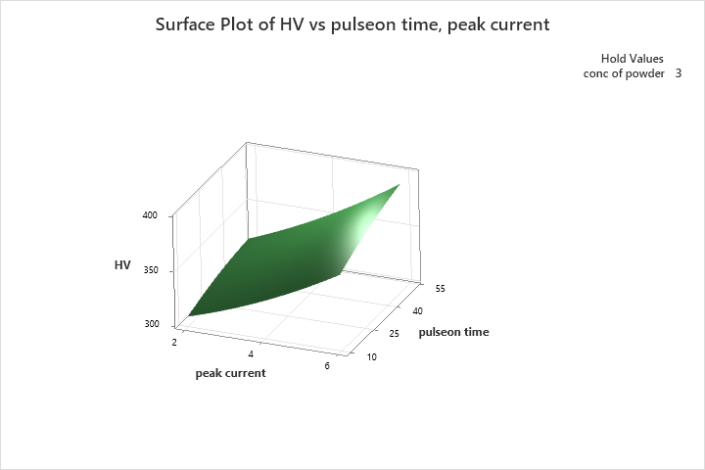

FIG.4.10

* By increasing the peak current hardness is increasing and also by increasing the pulse on time hardness is slightly increasing.
  1. **DISCUSSION:**

By doing powder Mixed Electrical Discharge Machining Hardness is increasing and Surface roughness is decreasing by adding powder or increasing the concentration of powder so what we consider is correct and it is showing the good results.

**CHAPTER 5**

**CONCLUSION:**

* By increasing the concentration of powder surface roughness value is decreasing it is the good sign that the surface roughness is decreased after machined.
* By increasing the concentration of powder, hardness is also increasing so it is good sign that increasing of hardness after machining.
* The chromium powder gets deposited on m/c surface decreasing surface roughness.
* By increasing the concentration of powder, the conduction of spark b/w tool job is aided effecting less surrounding area around the machining area thus increasing surface hardness.
* Concentration at 6 g/l low surface roughness and high hardness at machined area.

**CHAPTER 6**

**REFRENCES:**

1. A systematic review on powder mixed electrical discharge machining by Anand Y. Joshi et.al.
2. Experimental investigation of powder mixed EDM AISI P20 Steel using different powders and different tool materials by Dr. S. Ramesh et .al
3. Experimental Investigation on Silicon Powder Mixed-EDM of Nimonic-90 Superalloy by pragya Shandaliya et .al
4. Powder Mixed Electric Discharge Machining: Process Parameters Analysis by S. Kalyanasundaram et .al
5. State-of-the-art Powder Mixed Electric Discharge Machining (PMEDM) Process: A Review by M. Kumar et .al
6. Modeling and Optimization of Powder Mixed Electric Discharge Machining (PMEDM) Process Parameters by R. Thakur and B. Kumar et .al
7. Effect of Powder-Mixed Dielectric on EDM Performance Using Powder Suspension in a Vegetable Oil Dielectric by D. B. Ghorui et .al
8. Advances in Powder Mixed Electro-Discharge Machining (PMEDM): Techniques, Applications, and Future Prospects edited by M. S. Shunmugam et .al
9. Experimental Investigation of Surface Roughness in Powder Mixed EDM of AISI D3 Steel by V. Soundararajan et .al
10. Effect of Powder Mixed Dielectric on Surface Integrity of Inconel 718 During Electric Discharge Machining by S. Yadava et .al
11. Optimization of Machining Parameters in Powder Mixed Electrical Discharge Machining (PMEDM) of Titanium Alloy (Ti-6Al-4V) by A. Sharma et .al
12. A Review on Powder Mixed Dielectric in Electrical Discharge Machining by P.Yuvraj Singh et .al
13. "Powder Mixed Electrical Discharge Machining" by P. M. Pandey et .al

**CHAPTER 7**

**Self-Evaluation Form for Group Work**

**7.1 SELF EVALUATION FORMS:**

**Your Name:** Bhaswanth sriramana

|  |  |  |  |
| --- | --- | --- | --- |
|  | seldom | sometimes | often |
| Contributed good ideas |  |  |  |
| Listened to and respected the ideas of others |  |  |  |
| Compromised and cooperated |  |  |  |
| Took initiative where needed |  |  |  |
| Came to meetings prepared |  |  |  |
| Communicated effectively with teammates |  |  |  |
| Did my share of the work |  |  |  |

**Your Name:** Venkat Sai Praneeth

|  |  |  |  |
| --- | --- | --- | --- |
|  | seldom | sometimes | often |
| Contributed good ideas |  |  |  |
| Listened to and respected the ideas of others |  |  |  |
| Compromised and cooperated |  |  |  |
| Took initiative where needed |  |  |  |
| Came to meetings prepared |  |  |  |
| Communicated effectively with teammates |  |  |  |
| Did my share of the work |  |  |  |

**Your Name:** Chanakya Reddy

|  |  |  |  |
| --- | --- | --- | --- |
|  | seldom | sometimes | often |
| Contributed good ideas |  |  |  |
| Listened to and respected the ideas of others |  |  |  |
| Compromised and cooperated |  |  |  |
| Took initiative where needed |  |  |  |
| Came to meetings prepared |  |  |  |
| Communicated effectively with teammates |  |  |  |
| Did my share of the work |  |  |  |

**7.2 PEER EVALUATION FORMS FOR GROUP WORK:**

|  |  |  |
| --- | --- | --- |
| Evaluation Criteria for Bhaswanth | Group member: Praneeth | Group member: Chanakya Reddy |
| Attends group meetings regularly and arrives on time |  |  |
| Contributes meaningfully to group discussions. |  |  |
| Completes group assignments on time. |  |  |
| Prepares work in a quality manner. |  |  |
| Demonstrates a cooperative and supportive attitude. |  |  |
| Contributes significantly to the success of the Mini project. |  |  |
| TOTALS |  |  |

|  |  |  |
| --- | --- | --- |
| Evaluation Criteria for Praneeth | Group member: Bhaswanth | Group member: Chanakya Reddy |
| Attends group meetings regularly and arrives on time |  |  |
| Contributes meaningfully to group discussions. |  |  |
| Completes group assignments on time. |  |  |
| Prepares work in a quality manner. |  |  |
| Demonstrates a cooperative and supportive attitude. |  |  |
| Contributes significantly to the success of the Mini project. |  |  |
| TOTALS |  |  |

|  |  |  |
| --- | --- | --- |
| Evaluation Criteria for Chanakya Reddy | Group member: Praneeth | Group member: Bhaswanth |
| Attends group meetings regularly and arrives on time |  |  |
| Contributes meaningfully to group discussions. |  |  |
| Completes group assignments on time. |  |  |
| Prepares work in a quality manner. |  |  |
| Demonstrates a cooperative and supportive attitude. |  |  |
| Contributes significantly to the success of the Mini project. |  |  |
| TOTALS |  |  |